**PROTECTION AND PERMANENCY M EMORANDUM, 14-13**

**TO:** Service Region Administrators

Service Region Administrator Associates

Service Region Clinical Associates

Regional Program Specialists

Family Services Office Supervisors

**FROM:** Tina Webb, Assistant Director

Division of Protection and Permanency

**DATE:**  November 7, 2014

**SUBJECT:** TWIST Instructions:Moving an OOHC Case to the Ongoing Function and Re-Entry of Aged Out Youth

The purpose of this memorandum is to provide TWIST instruction for staff regarding how to properly:

* Move an investigation, involving a child in out of home care, to the ongoing function; and
* Re-enter an aged out youth back into the system.

1. **Moving an OOHC case to the ongoing function:** It has been discovered that information on the TWS-M004 Case Listing report is not being captured accurately, in regards to cases being moved to the ongoing function in c-TWIST. I-TWIST tip-030 has recently been issued addressing this matter. The content of that tip is contained within this memorandum, with additional content added to include how to move an OOHC case to the ongoing function, and ensure that it populates correctly in c-TWIST. Completing the steps below will ensure that the case is considered a “true ongoing case” for purposes of the M004:   
     
     
   * Before i-twist, when a case was **open** in the ongoing function, but there were **no open program/subprograms**, the ongoing case would remain open even after a referral was entered and then closed:

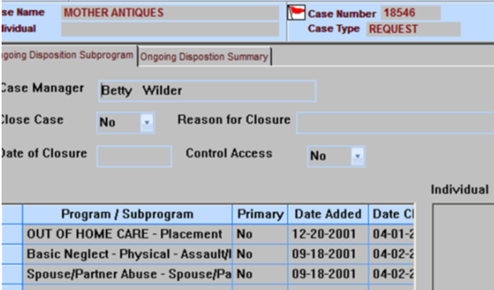

* Since the implementation of **i-twist**, when a case is **open** in the ongoing function, but there are **no open program/subprograms**, the case will **close** in the ongoing function when a new intake is entered and the assessment outcome is “close referral:”

When working on an assessment in a case with the above scenario, if the case is to stay open:

* **Modify the report adding a program/subprogram** (such as Risk of Harm) with a finding of “**Services Needed**;” then
* Select “**In home ongoing case**.**”**
* After the assessment is submitted and approved, the case will remain open in the ongoing function.

Please be aware that the “**OUT OF HOME CARE-Placement**” program/subprogram is not enough for the case to remain open in ongoing function, and be considered a “**true ongoing case**” on the M004. Staff must ensure that at least one other program/subprogram remains open (e.g. Basic Neglect-Physical-Assault, Spouse/Partner Abuse, etc.) in order for the case to continue into the ongoing function in c-TWIST.

1. **Re-entry of an aged out youth:** When a youth who has formerly aged out of OOHC, decides to recommit prior to their nineteenth (19th) birthday, please ensure that centralized intake staff follow the instructions below, to ensure that the youth is appropriately entered into TWIST:
   * Enter the youth into the case from which they exited care, ensuring that the youth is assigned their original Individual ID number;
   * Select the “dependency” subprogram and enter the youth’s birthday in a way that indicates he/she is under the age of eighteen (18); and
   * Assign the intake to the county where the youth is currently residing.

Once the case moves from intake to investigation, the SSW assigned to the investigation:

* Completes the Enter/Exit screens; and
* Corrects the youth’s date of birth to reflect his/her accurate age.

If you have any questions regarding moving a case to the ongoing function, please contact:

Tracy DeSimone, Quality Assurance and Policy Development (QAPD)

[Tracy.desimone@ky.gov](mailto:Tracy.desimone@ky.gov)

(502) 564-7635, ext. 3571

Or

Gretchen Marshall, QAPD Branch Manager

[Gretchen.marshall@ky.gov](mailto:Gretchen.marshall@ky.gov)

(502) 564-7635, ext. 3587

If you have any questions regarding re-entry of a`n aged out youth into TWIST, please contact Gretchen Marshall.